Embodied-Relational Therapy  16th Training, starting June 2025  Selection Process | 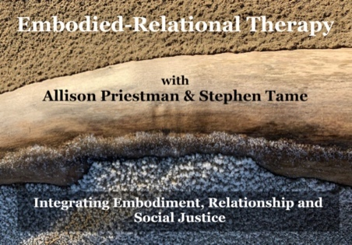

- The ERT training builds on practitioners' existing skills and experiences, and you will find yourself working therapeutically with your peers throughout the training.
- A core example of the capacity we aim to build on, is for you to be able to be in touch with yourself, whilst in therapeutic contact with another - to witness and regulate your emotions, whilst connecting with the world of another human being.
- As we see the relationship between participant and trainers is key, we want you to have a chance to experience working with us before deciding on choosing us as trainers.
- Our experience is that meeting and working together gives the best opportunity for us, together with you, to find out if this is the right training for you at this time.
To get ready to book your place, you need:
1) To read and consider the course brochure, and the course application questions
2) To attend an ERT practitioner led workshop, webinar or training (SEE BELOW)
3) To apply for the course - simply send us an email telling us that you want to apply
4) Meet both Allison and Stephen, at least one of us in the flesh. Ideally at a workshop.
5) Attend an informal mutual interview with either one of us (We're offering these from January onwards)
6) For both yourself and us to have agreed that the course is right for you at this time
7) To be aware that we expect you to commit to the whole first year course and to paying for the whole first year course
8) To have a commitment to anti-oppressive practise, and to have already begun the journey of exploring issues of rank, power, privilege and oppression. (We can offer signposting if it is helpful)
- We expect you to have undertaken a solid period of therapy before you start the course
- The course, working with relational embodiment, is impactful. We ask you to think about what therapeutic support you will need during the course. This may be a return to regular therapy
- To consider what other resources you may wish to put in place to help integrate the training into your life and practice
PLEASE NOTE: The application process is now open - simply send us an email to apply. We will be offering interviews for places on the course from Monday 6th January 2025 onwards. Feel free to contact us in the meantime with any questions or queries you may have.

To book your place, you then need to:
- Complete the booking form and send it to Allison
- Pay the non-returnable £500 deposit and agree a payment plan with Stephen
N.B. There is no charge for the selection process.
THE CLOSING DATE FOR BOOKING FORMS is 1st May 2025

PREPARATORY WORKSHOPS
For details of upcoming ERT workshops run by Allison, Stephen and ERT practitioners, go to: www.erthworks.co.uk
Ideally, you would attend our in-the-flesh workshop with Allison and Stephen:
15-16 Feb 2025 Relational Body Psychotherapy - an ERT Approach
However, if this is not possible, you could instead attend a web-based workshop with Allison: Non-visible disability and long-term health conditions. Saturday 15 March, 2025. 10am-1pm
Or, if it is easier for you to attend a workshop in the north of England, another possibility is this 2 weekend series with our ERT colleague, Jayne Johnson:
Radical Embodiment 15/02/2025 - 16/02/2025

Course Contact Details:
ERT training admin: trainersert@gmail.com
Stephen: stephentame@gmail.com Allison: allisonpriestman@gmail.com

Please see Fee Document for Course Cost

