Embodied-Relational Therapy  16th Training, starting June 2025  Application Questions | 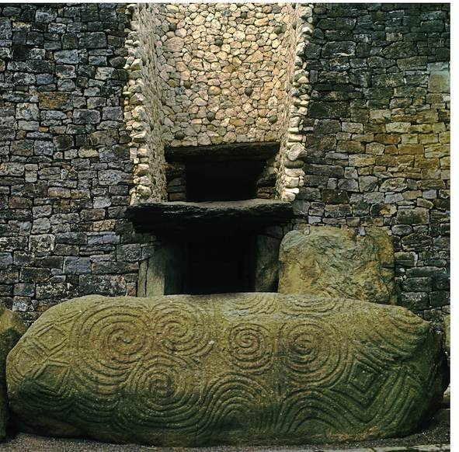

We ask you to read and consider the questions below before arranging an informal interview with us.
You do not need to write down your responses.

-What are your dreams/goals/expectations/aims for the course? How do you hope to change?
-Do you have any worries or fears about the training that you’d like to share?
-It would help us to decide if this is the right course for you if you can let us know about your experience as a client in one-to-one therapy? Are you currently in therapy?
-What are your learning edges professionally/ personally?
-What personal and professional support do you have in place for the duration of the training?
-Can you make all the dates?
-What has been your experience of training, and of group process?
- We expect participants to be committed to ongoing learning about anti-oppressive practice and we will ask you about this when we speak.
- During the 2 years, we will be encouraging you to deepen your awareness of your own experiences of power, privilege and marginalisation – the ways in which discrimination and privilege play out both in our bodies, and the bodies of those we work with. How does this land with you as read this?

-Please can you let us know if you have any access needs that you would like us to take account of? Particularly in terms of our delivery of the training.
-Finally, do you have any questions about the course that you would like to ask us?

Please note that:
The 2025 training has been specifically designed as both a training in Embodied-Relational Therapy, to lead into a training for trainers - a route into co-creating the new ERT Training Collective.
The first and second year will each consist of five residentials.
On the second year, a small number of ERT graduates are likely to join us for revision and training update, and to potentially join the training for trainers modules and help co-create the training collective. All will be expected to join the first residential of the advanced year, so that you get to meet everybody at the beginning of that year, therefore the first residential is likely to be a slightly larger group.
There will be times when we will be encouraging trainees to step into leadership and training roles within the group. We will be making space to explore the inherent complexity of groups and roles.
The 2-year modular ERT training is postgraduate, for people already qualified in counselling, psychotherapy or therapeutic bodywork; we occasionally accept someone who is not qualified as a counsellor or psychotherapist but who has relevant qualities and experience, on the understanding that this training alone will not lead to accreditation as a psychotherapist or counsellor.
Our experience is that having training groups made up of people from a wide range of modalities, with a wide range of experiences and qualifications enriches the learning experience for us all.

THE CLOSING DATE FOR BOOKING FORMS is 1st May 2025

For details of upcoming ERT workshops run by Allison, Stephen and ERT practitioners:
www.erthworks.co.uk
For questions, queries and booking forms:
Admin: trainersert@gmail.com
Stephen: stephentame@gmail.com Allison: info@allisonpriestman.co.uk

