Embodied-Relational Therapy  15th Training, starting April 2022  Selection Process | 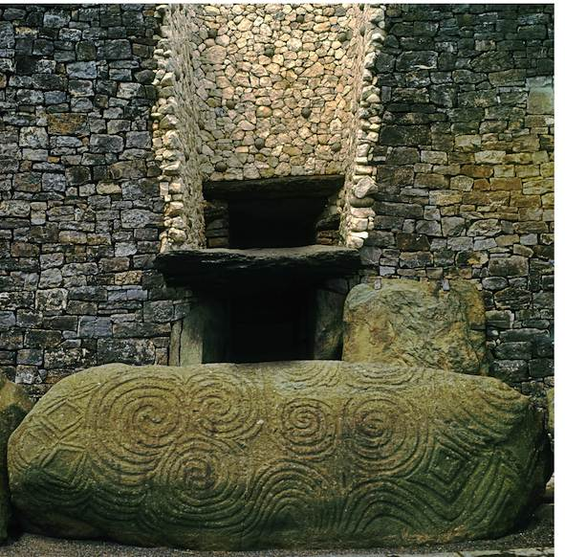

To get ready to book your place, you need:
- To read and consider the course brochure, and the course application questions.
- To attend an Embodied-Relational Therapy workshop or webinar with Allison Priestman, Jayne Johnson, Stephen Tame, or Nick Totton leading.
- To have an informal mutual interview with Stephen or Allison.
- To have had a phone conversation with, or to have met, both Stephen and Allison.
- For both yourself and us to have agreed that the course is right for you at this time.
- To be aware that we expect you to commit to the whole first year course and to paying for the whole first year course.
- To consider what resources you may wish to put in place to help integrate the training into your life and practice.
To book your place, you then need to:
- Complete the booking form and send it to Annie.
- Pay the £500 deposit and agree a payment plan with Annie.
N.B. There is no charge for the selection process.
THE CLOSING DATE FOR BOOKING FORMS is 18th March 2022
For details of upcoming ERT workshops run by Nick, Allison, Jayne, or Stephen:
www.erthworks.co.uk
Contact Details:
Annie (ERT training admin): trainersert@gmail.com
Stephen: stephentame@gmail.com
Allison: info@allisonpriestman.co.uk
Cost:
Year one cost: £3450 or earlybird £3150 if booked before 7th January 2022

Price includes all teaching, all meals, accommodation, handouts and online documents, and admin.
We ask for an initial deposit of £500.
We are committed to making the course as affordable as is possible. We therefore offer a very flexible approach to payment plans. It is possible to pay upfront, monthly (from time of booking if helpful), at each residential, or we will agree other payment plans to suit you.
For those on low income, we are able to offer up to three concessionary places, of £350 reduction.

